Вид страницы PlayerPage
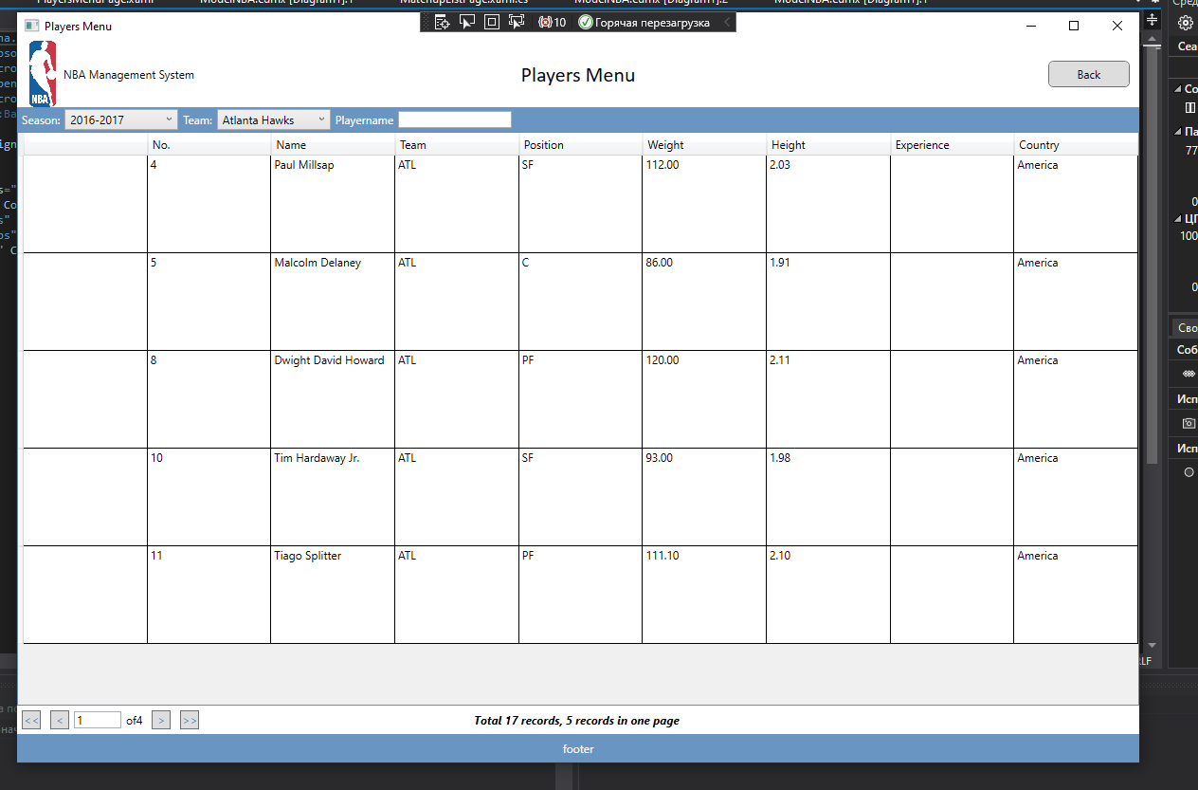
PlayerPage.Haml
<Grid>
<Grid.RowDefinitions>
<RowDefinition Height="Auto"/>
<RowDefinition Height="*"/>
<RowDefinition Height="Auto"/>
</Grid.RowDefinitions>

<StackPanel Grid.Row="0" Background="{StaticResource MainBlue}" Orientation="Horizontal">
<Label Content="Season:" Foreground="White"></Label>
<ComboBox Name="CmbSeasons" DisplayMemberPath="Name" SelectionChanged="UpdatePlayerDataGrid"></ComboBox>
<Label Content="Team:" Foreground="White"></Label>
<ComboBox Name="CmbTeam" DisplayMemberPath="TeamName" SelectionChanged="UpdatePlayerDataGrid"></ComboBox>
<Label Content="Playername" Foreground="White"></Label>
<TextBox Name="TxtPlayerName" TextChanged="TxtPlayerName_TextChanged"></TextBox>
</StackPanel>
<DataGrid x:Name="GridPlayres" Grid.Row="1" AutoGenerateColumns="False" ColumnWidth="*" IsReadOnly="True">
<DataGrid.Columns>
<DataGridTemplateColumn Header="">
<DataGridTemplateColumn.CellTemplate>
<DataTemplate>
<Image Width="100" Height="100" Source="{Binding Player.Img }"></Image>
</DataTemplate>
</DataGridTemplateColumn.CellTemplate>
</DataGridTemplateColumn>
<DataGridTextColumn Header="No." Binding="{Binding ShirtNumber}"></DataGridTextColumn>
<DataGridTextColumn Header="Name" Binding="{Binding Player.Name}"></DataGridTextColumn>
<DataGridTextColumn Header="Team" Binding="{Binding Team.Abbr}"></DataGridTextColumn>
<DataGridTextColumn Header="Position" Binding="{Binding Player.Position.Abbr}"></DataGridTextColumn>
<DataGridTextColumn Header="Weight" Binding="{Binding Player.Weight}"></DataGridTextColumn>
<DataGridTextColumn Header="Height" Binding="{Binding Player.Height}"></DataGridTextColumn>
<DataGridTextColumn Header="Experience" Binding="{Binding Player.Experience}"></DataGridTextColumn>
<DataGridTextColumn Header="Country" Binding="{Binding Player.Country.CountryName}"></DataGridTextColumn>
</DataGrid.Columns>
</DataGrid>
<Grid Grid.Row="2">
<StackPanel Orientation="Horizontal">
<StackPanel.Resources>
<Style TargetType="Button" BasedOn="{StaticResource PadinationButton}"></Style>
</StackPanel.Resources>
<Button Click="GoToFirstPage" Content="&lt;&lt;"></Button>
<Button Click="GoToPreviousPage" Content="&lt;"></Button>
<TextBox Name="TxtCurrentPage" Width="50"></TextBox>
<Label Name="LblTotalPages">of 7</Label>
<Button Click="GoToNextPage" Content="&gt;"></Button>
<Button Click="GoToLastPage" Content="&gt;&gt;"></Button>
</StackPanel>
<Label Name="LblSummaryInfo" HorizontalAlignment="Center" FontStyle="Italic" FontWeight="Bold"></Label>
</Grid>

</Grid>
</Page>
PlayerPage.Haml.cs
using System;
using System.Collections.Generic;
using System.Linq;
using System.Text;
using System.Threading.Tasks;
using System.Windows;
using System.Windows.Controls;
using System.Windows.Data;
using System.Windows.Documents;
using System.Windows.Input;
using System.Windows.Media;
using System.Windows.Media.Imaging;
using System.Windows.Navigation;
using System.Windows.Shapes;

namespace BasketbolGaliullina.Pages
{
/// <summary>
/// Логика взаимодействия для PlayersMenuPage.xaml
/// </summary>
public partial class PlayersMenuPage : Page
{
// Создание переменной для вывода данных из БД.

NBAShot_03Entities _context;
private int _currentPage = 1;
private int _countPlayrs = 5;
private int _maxPages;
public PlayersMenuPage()
{

InitializeComponent();
//соединение БД.
_context = new NBAShot_03Entities();
// вывод данных из БД в таблицу.
GridPlayres.ItemsSource = _context.PlayerInTeams.ToList();
//Вывод данных в ComboBox из БД и сортировка данных по возростанию.
CmbSeasons.ItemsSource = _context.Seasons.OrderByDescending(season=> season.Name).ToList();
CmbTeam.ItemsSource = _context.Teams.OrderBy(team=> team.TeamName).ToList();
CmbSeasons.SelectedIndex = 0;
CmbTeam.SelectedIndex = 0;
RefreshPlayers();
}

private void UpdatePlayerDataGrid(object sender, SelectionChangedEventArgs e)
{
// Вызов метода.
RefreshPlayers();
}
// Создание метода для фильтрации и поиска из таблицы.
private void RefreshPlayers()
{
Team selectedTeam = CmbTeam.SelectedItem as Team;
Season selectedSeason = CmbSeasons.SelectedItem as Season;
string searchText = TxtPlayerName.Text;
List<PlayerInTeam> listPlayers = _context.PlayerInTeams.ToList();
listPlayers = listPlayers.Where(x => x.Season == selectedSeason).ToList();
listPlayers = listPlayers.Where(x => x.Team == selectedTeam).ToList();
if (!string.IsNullOrWhiteSpace(searchText))
{
listPlayers = listPlayers.Where(x => x.Player.Name.ToLower().Contains(searchText.ToLower())).ToList();
}
// Вывод порядкового номера по возростанию.
listPlayers = listPlayers.OrderBy(x => x.ShirtNumber).ToList();
GridPlayres.ItemsSource = listPlayers;
_maxPages = (int)Math.Ceiling(listPlayers.Count * 1.0 / _countPlayrs);

var listPlayersInPage = listPlayers.Skip((_currentPage - 1) * _countPlayrs).Take(_countPlayrs).ToList();
TxtCurrentPage.Text = _currentPage.ToString();
LblTotalPages.Content = "of" + _maxPages;
LblSummaryInfo.Content = $"Total {listPlayers.Count} records, { _countPlayrs} records in one page ";
GridPlayres.ItemsSource = listPlayersInPage;
}

private void TxtPlayerName_TextChanged(object sender, TextChangedEventArgs e)
{
// вызов метода
RefreshPlayers();
}

private void GoToFirstPage(object sender, RoutedEventArgs e)
{
_currentPage = 1;
RefreshPlayers();
}

private void GoToPreviousPage(object sender, RoutedEventArgs e)
{
_currentPage--;
RefreshPlayers();
}

private void GoToNextPage(object sender, RoutedEventArgs e)
{
_currentPage++;
RefreshPlayers();
}

private void GoToLastPage(object sender, RoutedEventArgs e)
{
_currentPage = _maxPages;
RefreshPlayers();
}
}
}

